DECISION TREE INDUCTION (ID3 ALGORITHM)
Loan Approval Prediction: Questions and Answers
SCENARIO (15 Marks)
A company wants to predict whether a loan applicant's application should be approved based on the applicant's income, credit score, and existing loan status.

QUESTION 1
Create a sample dataset containing at least 10 records.
Answer:
We take 12 loan applicants. Each row is one applicant, with their Income, Credit Score, Existing Loan status and the decision (Approved).
No. | Income | Credit Score | Existing Loan | Approved
1 | High | Good | No | Yes
2 | High | Good | Yes | Yes
3 | High | Fair | No | Yes
4 | High | Poor | Yes | No
5 | Medium | Good | No | Yes
6 | Medium | Fair | Yes | No
7 | Medium | Poor | No | No
8 | Medium | Good | Yes | Yes
9 | Low | Good | No | Yes
10 | Low | Fair | Yes | No
11 | Low | Poor | No | No
12 | Low | Fair | No | No

Total records = 12 (6 Approved = Yes and 6 Approved = No).

QUESTION 2
Identify the target class and predictor attributes.
Answer:
Type | Attribute
Target class (what we predict) | Approved (Yes / No)
Predictor attribute 1 | Income (High / Medium / Low)
Predictor attribute 2 | Credit Score (Good / Fair / Poor)
Predictor attribute 3 | Existing Loan (Yes / No)

Target class: the output we want to predict. Here it is whether the loan is Approved (Yes) or not (No).
Predictor attributes: the inputs used to make the prediction. Here they are Income, Credit Score and Existing Loan.

QUESTION 3
Construct a decision tree using the ID3 algorithm.
Answer:

Basic ideas
Decision tree: a flowchart-like tree. Each inner node asks about an attribute, each branch is an answer, and each leaf gives the final decision.
ID3: builds the tree by choosing, at every step, the attribute with the highest Information Gain, splitting the data on it, and repeating for every branch until each group has only one answer.
Entropy: tells how mixed the data is. 0 = all records have the same answer (pure). 1 = answers are mixed 50-50.
Information Gain: how much the entropy reduces after splitting on an attribute. Higher gain means a better attribute.
Entropy(S) = − Σ pᵢ · log₂(pᵢ)
Info(A) = Σ ( records in branch / total records ) × Entropy(branch)
Gain(A) = Entropy(S) − Info(A)

Steps to build the tree
Step 1: Entropy of the whole dataset. 6 Yes and 6 No out of 12, so Entropy(S) = 1.000.
Step 2: Find the gain of each attribute for the root. (Full calculation is shown in Question 4.)
Attribute | Info(A) | Information Gain
Income | 0.874 | 0.126
Credit Score | 0.270 | 0.730 (HIGHEST)
Existing Loan | 0.979 | 0.021

Credit Score has the highest gain, so it becomes the root node.
Step 3: Check each branch of Credit Score.
- Good: all 5 records are Yes. Pure, so leaf = Approved.
- Poor: all 3 records are No. Pure, so leaf = Rejected.
- Fair: 1 Yes and 3 No. Mixed, so split again.
Step 4: Split the Fair branch. Using only the 4 records with Credit Score = Fair: Gain(Income) = 0.811 and Gain(Existing Loan) = 0.311. Income is higher, so the Fair branch is split on Income.
Step 5: Check the Income branches. High gives Approved, Medium gives Rejected, Low gives Rejected. All are pure, so the algorithm stops. Existing Loan is not used.
Tree in text form:
Credit Score
|-- Good --> APPROVED
|-- Poor --> REJECTED
|-- Fair --> Income
|-- High --> APPROVED
|-- Medium --> REJECTED
|-- Low --> REJECTED
The diagram is drawn in Question 5.

QUESTION 4
Show the attribute selection process using Information Gain for at least one split.
Answer:
We show the full calculation for the root split (all three attributes) and for the second split (Fair branch).

A. Root node split
Step 1: Entropy of the whole dataset. Yes = 6, No = 6, Total = 12.
Entropy(S) = −(6/12) log₂(6/12) − (6/12) log₂(6/12) = 0.5 + 0.5 = 1.000
Step 2: Gain of each attribute.

(a) Income
Value | Total | Yes | No | Entropy
High | 4 | 3 | 1 | 0.811
Medium | 4 | 2 | 2 | 1.000
Low | 4 | 1 | 3 | 0.811

How 0.811 comes: −(3/4) log₂(3/4) − (1/4) log₂(1/4) = 0.311 + 0.500 = 0.811.
Info(Income) = (4/12)(0.811) + (4/12)(1.000) + (4/12)(0.811) = 0.874
Gain(Income) = 1.000 − 0.874 = 0.126

(b) Credit Score
Value | Total | Yes | No | Entropy
Good | 5 | 5 | 0 | 0.000
Fair | 4 | 1 | 3 | 0.811
Poor | 3 | 0 | 3 | 0.000

Good has only Yes and Poor has only No, so both are pure and their entropy is 0.
Info(Credit Score) = (5/12)(0) + (4/12)(0.811) + (3/12)(0) = 0.270
Gain(Credit Score) = 1.000 − 0.270 = 0.730

(c) Existing Loan
Value | Total | Yes | No | Entropy
No | 7 | 4 | 3 | 0.985
Yes | 5 | 2 | 3 | 0.971

Info(Existing Loan) = (7/12)(0.985) + (5/12)(0.971) = 0.979
Gain(Existing Loan) = 1.000 − 0.979 = 0.021
Step 3: Compare the gains.
Attribute | Info(A) | Information Gain
Income | 0.874 | 0.126
Credit Score | 0.270 | 0.730 (HIGHEST)
Existing Loan | 0.979 | 0.021

Result: Credit Score has the highest Information Gain (0.730), so it is selected as the root node.

B. Second split (Credit Score = Fair branch)
Take only the 4 records where Credit Score = Fair:
No. | Income | Credit Score | Existing Loan | Approved
3 | High | Fair | No | Yes
6 | Medium | Fair | Yes | No
10 | Low | Fair | Yes | No
12 | Low | Fair | No | No

Entropy(Fair) = −(1/4) log₂(1/4) − (3/4) log₂(3/4) = 0.500 + 0.311 = 0.811
Income: High → {Yes}, Medium → {No}, Low → {No, No}. Every group is pure, so Info = 0.
Gain(Income) = 0.811 − 0 = 0.811
Existing Loan: No → {Yes, No} (entropy 1), Yes → {No, No} (entropy 0).
Info = (2/4)(1) + (2/4)(0) = 0.5 Gain = 0.811 − 0.5 = 0.311
Result: Income has the higher gain (0.811 is more than 0.311), so the Fair branch is split on Income.

QUESTION 5
Draw the final decision tree and classify two new applicants.
Answer:

Final decision tree
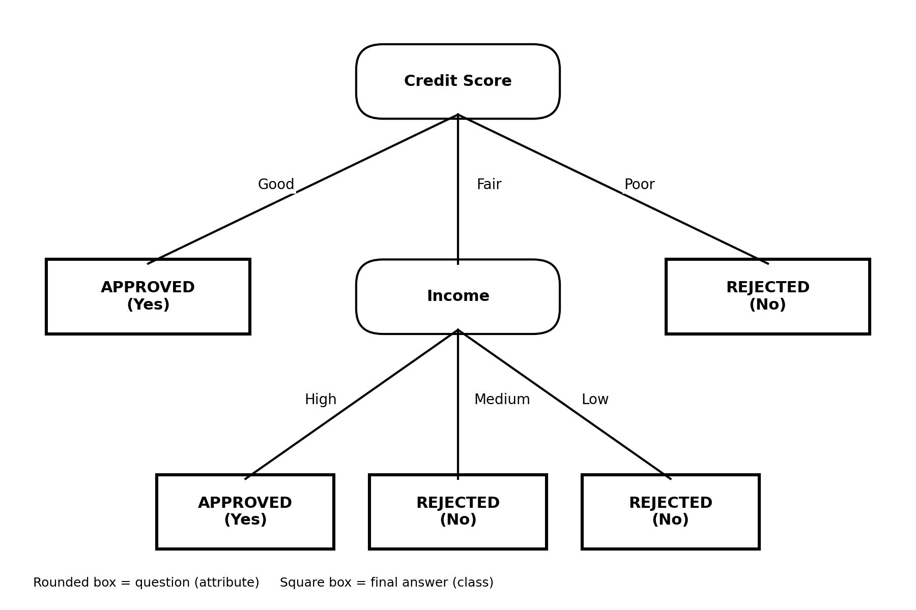

Rules from the tree
- IF Credit Score = Good THEN Approved = Yes
- IF Credit Score = Poor THEN Approved = No
- IF Credit Score = Fair AND Income = High THEN Approved = Yes
- IF Credit Score = Fair AND Income = Medium THEN Approved = No
- IF Credit Score = Fair AND Income = Low THEN Approved = No

Classifying two new applicants
Applicant | Income | Credit Score | Existing Loan | Prediction
A | Medium | Good | Yes | Approved
B | Low | Fair | No | Rejected

Applicant A: Start at the root. Credit Score = Good, so we reach the leaf directly. Prediction = Approved. (Income and Existing Loan are not even checked.)
Applicant B: Start at the root. Credit Score = Fair, so go to the Income node. Income = Low, so we reach the leaf. Prediction = Rejected.

Conclusion
Credit Score was chosen as the root because it had the highest Information Gain (0.730). The Fair branch was split on Income (gain 0.811). Existing Loan had very little gain (0.021) and was not used. The tree classifies all 12 training records correctly. Applicant A is predicted Approved and Applicant B is predicted Rejected.

